
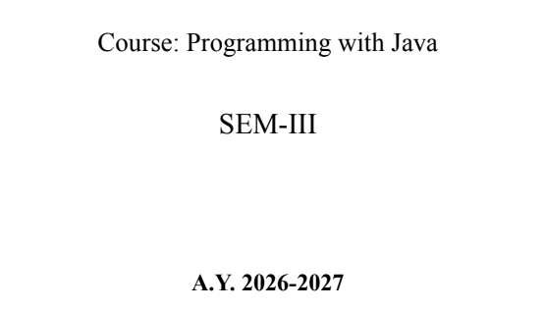
NAME: BHOOMI VIJAYVARGIYA
BATCH: A2
PRN: 25070122062

ASSIGNMENT-3
TITLE : Develop a Java application demonstrating method overloading and the use of static variables, methods in class design.
Problem Statement
Develop a Java application demonstrating method overloading and the use of static variables, methods in class design.
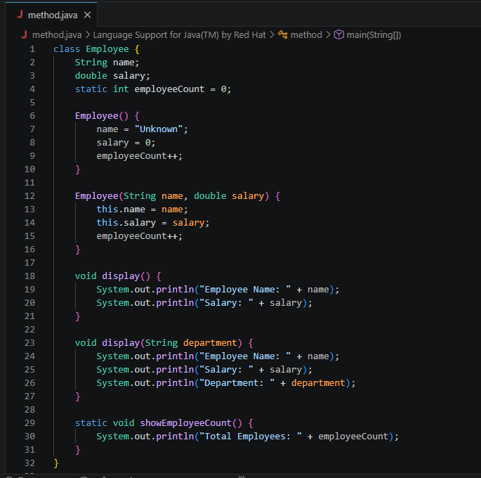
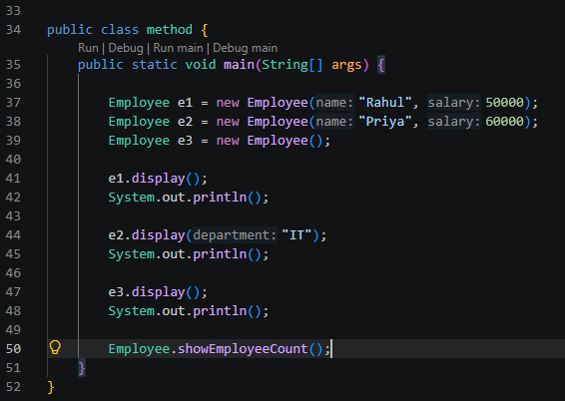
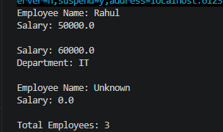
Learning Objectives
To implement method overloading and use static variables and methods in Java programs.
Theory
Method overloading allows multiple methods to have the same name with different parameter lists, enabling compile-time polymorphism. The static keyword is used for variables and methods that belong to the class instead of individual objects. Static members share common data among all objects and reduce memory usage. These concepts improve code flexibility, readability, and efficient resource management.
Outcome
• Understood and implemented method overloading in Java by creating methods with the same name but different parameter lists.
• Learned to use static variables for sharing data among all objects and static methods for class-level operations.
• Successfully developed applications such as a Calculator and a Restaurant Billing System using these concepts
Conclusion
The experiment successfully demonstrated the use of method overloading and static variables and methods in Java. Method overloading provided flexibility by allowing the same method to perform different tasks based on parameters, while static members efficiently managed shared data such as calculation counts and total orders. These features improve code reusability, maintainability, and efficient class design.
Exercise
- Develop a Calculator program using overloaded methods for addition of integers and decimals. Use a static variable to count calculations.
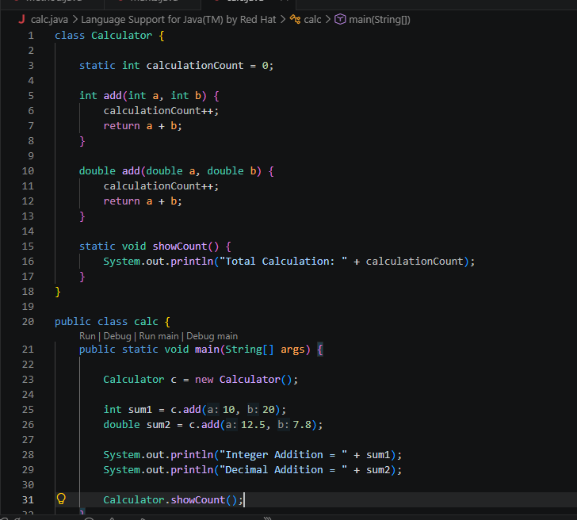

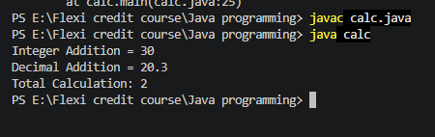

- Develop a Restaurant Billing Application where overloaded methods calculate bills for dine-in, takeaway, and delivery orders, while static variables track total orders.
